# Predict Draws

This Tab provides two functionalities:

1. Variable configuration as shown in Figure 1. You can tune the variables to whatever you need to.
2. Actual generating draw numbers for target draw (could be next draw, or any past draws pretending not known to you) as shown in Figure 2. You can get new generated draw (in RED color) by clicking submit button each time. If you do not satisfy the generated set of draw numbers (ex. For Lotto 6/49, the set draw number is 6, for Mega Millions, is 5, etc.), just keep clicking submit button and different set of draw numbers would be generated. Other numbers come up with each generating are for reference. That means you also can pick up some numbers from this group (in WHITE color) for your final draw. Most of time the final draw you pick are from both groups, not just simply pick the generated set numbers (in RED). To choose which numbers, usually you have to base on analysis from other tools on other tabs.



**Sum** means sum of all numbers of generated draw. The scope of sum is defined by **sum min** and **sum max** of these two fields. That means the sum of generated draw must fall in between these two values.

Select a lotto of your interest

Input next draw number or past known draw number

Number of HOT number to select

Definition for **HOT**. 1 means this number was hit on last jack-pot on, while 5 means the number was hit on 5 draws ago. 1 and 5 also called DISTANCE in the rest of the documents. The same definition also apply to **VERY HOT**, **SEMI HOT**, **SEMI COLD**, **COLD**, **VERY COLD** only the distance scope are different.

**Odds** means number of odd numbers in a generated draw can be allowed. Value 3 tells the tool that any draw generated must include 3 numbers to be odd.

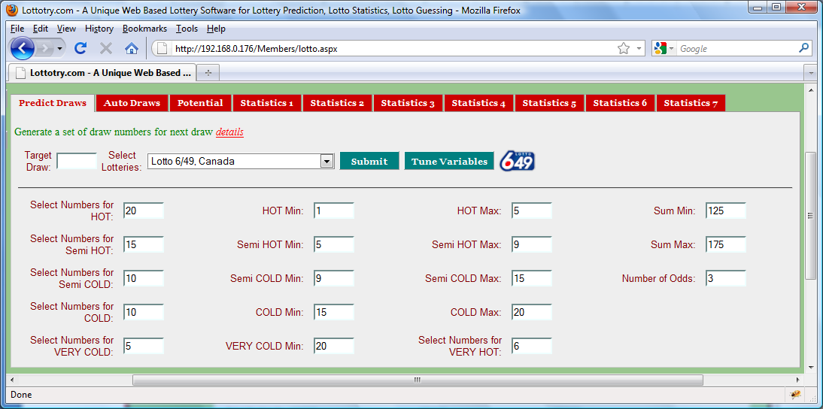

Figure : Variables Configuration

This one of generated draw number in RED color. **R:** relative distance, which means this number got hit 3 draws ago. **S:** saved distance, which means when this number (3) last time got hit from which its previous hit was 4 draws ago. **R** and **S** infer the recent history of this number to provide valuable info to the user in determining if this number is one of best choices or not, ***Statistics 3*** provides longer history of each numbers and better go through that statistics before making any final decision.

The numbers in WHITE color means that they are selected as potential alternatives for the draw numbers. They were generated because they have equally chance to hit the jack-pot as the RED one, they are in WHITE color only because they were not being chosen by generator this time. Therefore, when you select your final draw numbers, this group numbers must be considered equally to those RED ones. Go through other Statistics and tools before you make final decision.

Whole numbers from which draw numbers are generated. In Lotto 6/49 the number range is 1 – 49, while Mega Millions is 1 – 56 and Power Ball is 1 – 59, etc.

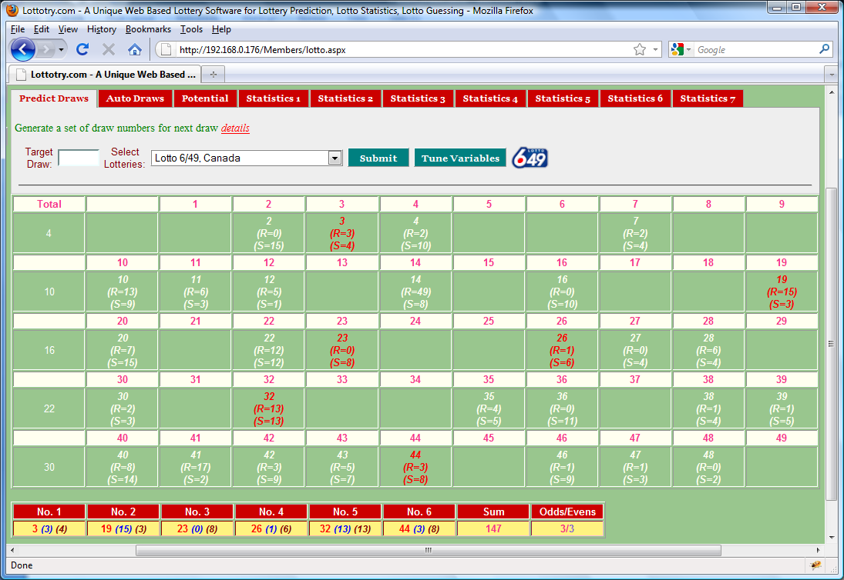

Sum of all draw numbers. This is one of facts to consider when making final decision

Blank means these numbers were filtered out. Because these numbers (in Blank) are considered as ‘DEAD’ by the tool. But don’t always think that way as HUMAN, considering the lotto’s randomness and un-predictability, these numbers could also be possible hitting the Jack-Pot. You need to go through and analysis other statistics and tools on other tabs to make final pick up.

Total numbers generated. 10 means accumulated number so far along each row of the tablet. 30 here is the total generated numbers for this submit. This number based on your configuration.

Figure : Generated a new Draw

One of generated draw numbers. (***1***) here is **R**: **Relative Distance** and which means this number got hit 1 draws ago. (***6***) here is **S**: **Saved Distance.** which means when this number (26) last time got hit from which its previous hit was 6 draws ago. **R** and **S** infer the recent history of this number to provide valuable info to the user in determining if this number is one of best choices or not, ***Statistics 3*** provides longer history of each numbers and better go through that statistics before making any final decision.

Shows the Odd and Even numbers in generated draw. This is info is one of important facts to consider when you facing dilemma on choosing which numbers.